TASK 10: Selenium Test Design and Local Execution for Healthy Habit Tracking Application
Project: Dockerized Book Issue and Return System
Name: Swar Sawalkar
Roll No.: 23104B0023
Department: CMPN, Fourth Year
Division: C

1. Aim
To identify critical user journeys in the Healthy Habit Tracking Application, design and implement automated test cases using Selenium WebDriver, execute the test suite locally through Maven, and generate test reports with screenshots captured automatically whenever a test fails.
2. Introduction
The Healthy Habit Tracking Application is designed to help users maintain a healthy lifestyle by tracking their daily habits and monitoring their progress. Users can perform activities such as registering an account, logging in, adding healthy habits, updating their daily progress, and viewing their habit-tracking information.
Testing the application manually for every operation can be time-consuming. Selenium WebDriver provides an automation framework that allows testers to simulate real user interactions with the application through a web browser.
In this experiment, Selenium WebDriver is used to automate important user journeys. Maven is used to manage project dependencies and execute the automated test suite. Assertions are included to verify expected application behaviour, while failure screenshots help identify errors during test execution.
3. Objectives
- Identify 3–5 critical user journeys in the Healthy Habit Tracking Application.
- Design automated test cases for important application functionalities.
- Implement Selenium WebDriver scripts using Java.
- Use assertions to verify expected results.
- Prepare suitable test data for different test scenarios.
- Capture screenshots automatically whenever a test case fails.
- Execute the Selenium test suite locally using Maven.
- Generate and analyse test execution reports.
4. Software and Tools Required
Tool | Purpose
Java | Programming language for automation scripts
Selenium WebDriver | Browser automation
Maven | Dependency management and test execution
TestNG | Test case execution and assertions
Chrome Browser | Application testing
ChromeDriver / Selenium Manager | Browser driver management
Eclipse / VS Code | Writing and managing test scripts
5. Critical User Journeys Identified
The following five critical user journeys are selected for testing.
1. User Registration
- Open the Healthy Habit Tracking Application.
- Navigate to the registration page.
- Enter username, email and password.
- Submit the registration form.
- Verify that the account is created successfully.
2. User Login
- Open the login page.
- Enter valid login credentials.
- Click the login button.
- Verify that the user is redirected to the dashboard.
3. Add a Healthy Habit
- Log in to the application.
- Navigate to the habit management section.
- Enter a habit name, such as Drinking Water.
- Select the frequency or daily target.
- Save the habit.
- Verify that the newly added habit appears in the habit list.
4. Update Daily Habit Progress
- Open the habit dashboard.
- Select an existing habit.
- Update its daily progress.
- Save the changes.
- Verify that the updated progress is displayed correctly.
5. View Habit Tracking Dashboard
- Log in to the application.
- Navigate to the dashboard.
- Check the displayed habits and progress information.
- Verify that the dashboard loads correctly and shows the expected data.
6. Test Plan and Test Cases
The following test cases are designed to verify the major functionalities of the application.
Test Case ID | Test Scenario | Test Data | Expected Result
TC01 | Register a new user | Name: Swar, Email: swar@test.com, Password: Test@123 | Account should be created successfully
TC02 | Login with valid credentials | Email: swar@test.com, Password: Test@123 | User should reach the dashboard
TC03 | Login with invalid credentials | Email: wrong@test.com, Password: Wrong@123 | Error message should be displayed
TC04 | Add a new healthy habit | Habit: Drinking Water, Target: 8 glasses | Habit should appear in the habit list
TC05 | Update daily habit progress | Habit: Drinking Water, Progress: 5 glasses | Updated progress should be displayed
TC06 | Open tracking dashboard | Registered user account | Dashboard should display habit information
7. Selenium WebDriver Implementation
Selenium WebDriver is used to automate browser operations such as opening web pages, entering data, clicking buttons and verifying displayed information.
The automation scripts are developed using Java and TestNG.
Maven Project Structure
HealthyHabitAutomation/
│
├── pom.xml
│
├── src/
│ └── test/
│ └── java/
│ └── tests/
│ ├── BaseTest.java
│ ├── RegistrationTest.java
│ ├── LoginTest.java
│ ├── HabitTest.java
│ └── DashboardTest.java
│
├── screenshots/
│
└── test-output/
Maven Dependencies
The following dependencies are added to the pom.xml file:
<dependencies>

<dependency>
<groupId>org.seleniumhq.selenium</groupId>
<artifactId>selenium-java</artifactId>
<version>4.27.0</version>
</dependency>

<dependency>
<groupId>org.testng</groupId>
<artifactId>testng</artifactId>
<version>7.10.2</version>
<scope>test</scope>
</dependency>

</dependencies>
BaseTest.java
This class initializes the Chrome browser before test execution and closes it after execution.
package tests;

import org.openqa.selenium.WebDriver;
import org.openqa.selenium.chrome.ChromeDriver;
import org.testng.annotations.BeforeMethod;
import org.testng.annotations.AfterMethod;

public class BaseTest {

protected WebDriver driver;

@BeforeMethod
public void setup() {

driver = new ChromeDriver();

driver.manage().window().maximize();

driver.get("http://localhost:8080");
}

@AfterMethod
public void tearDown() {

if (driver != null) {
driver.quit();
}
}
}
Note: The application URL should be changed according to the local deployment configuration.
LoginTest.java
This test verifies successful and unsuccessful login operations.
package tests;

import org.openqa.selenium.By;
import org.testng.Assert;
import org.testng.annotations.Test;

public class LoginTest extends BaseTest {

@Test
public void validLoginTest() {

driver.findElement(By.id("email"))
.sendKeys("swar@test.com");

driver.findElement(By.id("password"))
.sendKeys("Test@123");

driver.findElement(By.id("loginBtn")).click();

Assert.assertTrue(
driver.getCurrentUrl().contains("dashboard"),
"Login failed!"
);
}

@Test
public void invalidLoginTest() {

driver.findElement(By.id("email"))
.sendKeys("wrong@test.com");

driver.findElement(By.id("password"))
.sendKeys("Wrong@123");

driver.findElement(By.id("loginBtn")).click();

Assert.assertTrue(
driver.findElement(By.id("errorMessage")).isDisplayed(),
"Error message not displayed!"
);
}
}
HabitTest.java
This test verifies that a user can add a healthy habit.
package tests;

import org.openqa.selenium.By;
import org.testng.Assert;
import org.testng.annotations.Test;

public class HabitTest extends BaseTest {

@Test
public void addHabitTest() {

driver.findElement(By.id("habitName"))
.sendKeys("Drinking Water");

driver.findElement(By.id("target"))
.sendKeys("8");

driver.findElement(By.id("addHabitBtn")).click();

String habit = driver.findElement(
By.id("habitList")
).getText();

Assert.assertTrue(
habit.contains("Drinking Water"),
"Habit was not added!"
);
}
}
Note: The element IDs used in these examples are illustrative. They must match the actual HTML elements of the application.
8. Failure Screenshot Mechanism
Screenshots are useful for identifying errors when an automated test case fails.
Selenium WebDriver provides the TakesScreenshot interface to capture browser screenshots.
The following code can be added to the test framework:
package tests;

import java.io.File;
import java.nio.file.Files;
import java.nio.file.Paths;

import org.openqa.selenium.OutputType;
import org.openqa.selenium.TakesScreenshot;
import org.testng.ITestResult;
import org.testng.annotations.AfterMethod;

public class ScreenshotTest extends BaseTest {

@AfterMethod
public void captureFailure(ITestResult result) {

if (result.getStatus() == ITestResult.FAILURE) {

try {

Files.createDirectories(
Paths.get("screenshots")
);

File source = ((TakesScreenshot) driver)
.getScreenshotAs(OutputType.FILE);

Files.copy(
source.toPath(),
Paths.get(
"screenshots/" +
result.getName() + ".png"
)
);

System.out.println(
"Failure screenshot captured!"
);

} catch (Exception e) {
e.printStackTrace();
}
}
}
}
This mechanism captures a screenshot whenever a test fails and stores it inside the screenshots directory.
9. Local Execution Through Maven
Maven is used to compile the project, manage dependencies and execute the Selenium automation test suite.
Steps to execute:
- Open the Healthy Habit Automation project in VS Code or Eclipse.
- Ensure Java and Maven are installed.
- Start the Healthy Habit Tracking Application locally.
- Verify that the application is accessible through its local URL.
- Open the terminal in the project directory.
- Execute the following command:
mvn clean test
- Maven compiles the test scripts and executes the TestNG test cases.
- Review the execution output in the terminal.
- Check the generated reports and failure screenshots.
Generated output locations:
- TestNG report: test-output/index.html
- Failure screenshots: screenshots/
- Maven test reports: target/surefire-reports/
10. Expected Test Execution Results
The following table represents the expected behaviour of the designed test cases. Actual results should be filled in after running the suite.
Test Case | Expected Status
TC01 – User Registration | Pass
TC02 – Valid Login | Pass
TC03 – Invalid Login | Pass
TC04 – Add Healthy Habit | Pass
TC05 – Update Habit Progress | Pass
TC06 – View Dashboard | Pass
The above are expected outcomes, not verified execution results.
11. Test Reports and Screenshots
After executing the test suite, Maven and TestNG generate reports containing:
- Total number of test cases executed.
- Number of passed test cases.
- Number of failed test cases.
- Number of skipped test cases.
- Execution time.
- Failure details and error messages.
Screenshots captured during failures are stored in the screenshots folder. These screenshots help developers identify issues related to page loading, missing elements, incorrect navigation and unexpected application behaviour.
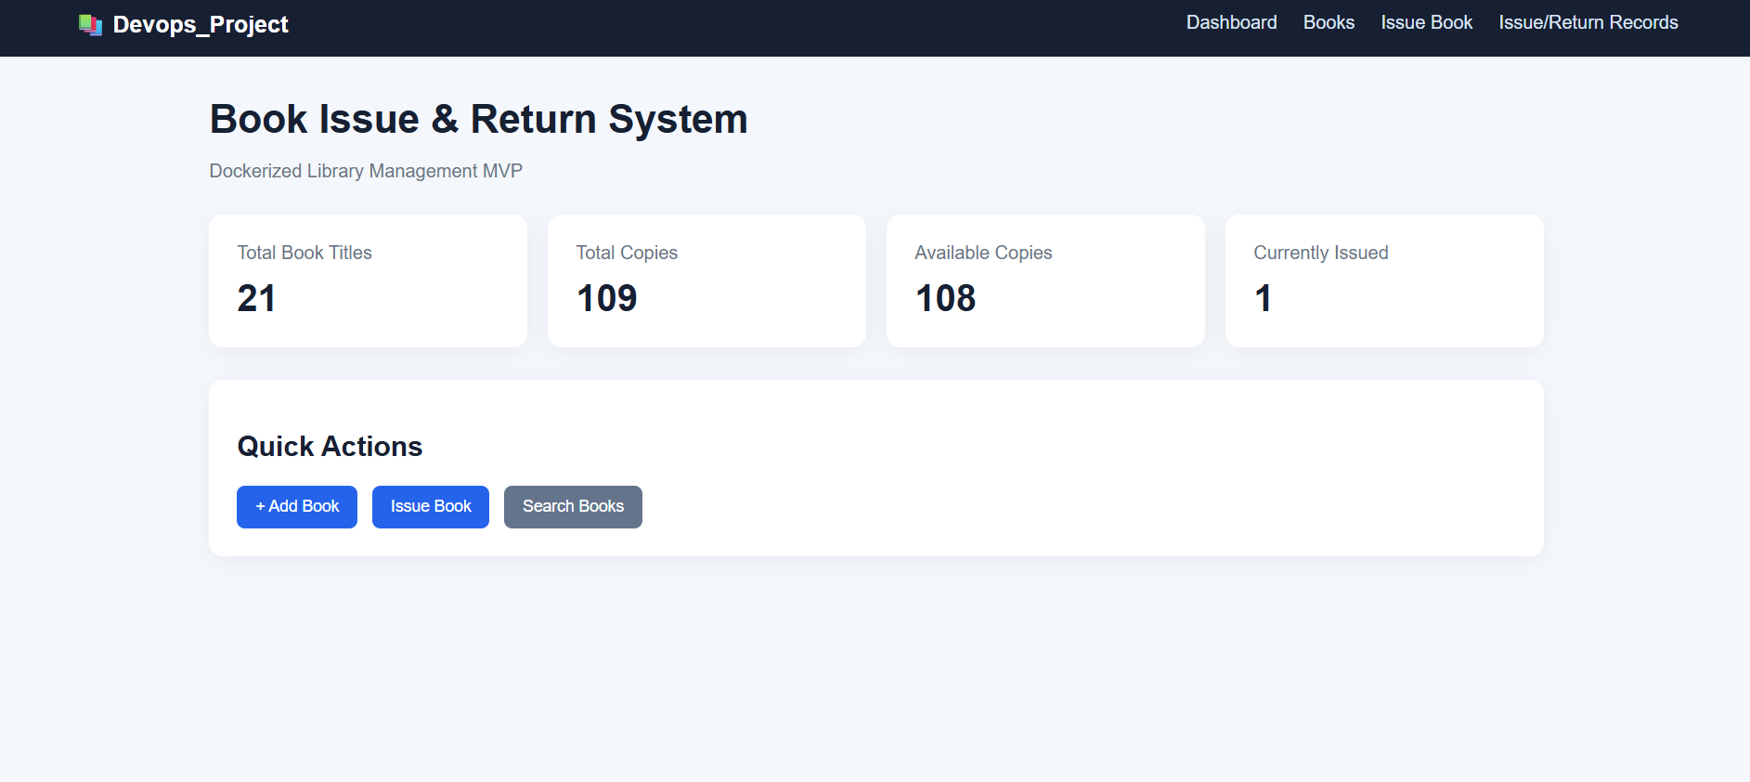

12. Advantages
- Reduces manual testing effort.
- Improves testing accuracy and consistency.
- Allows repeated execution of test cases.
- Helps identify functional issues quickly.
- Automatically captures screenshots for failed test cases.
- Maven simplifies dependency management and test execution.
- Test reports provide a clear overview of application quality.
13. Conclusion
In this experiment, Selenium WebDriver was used to design an automated testing approach for the Healthy Habit Tracking Application. Five important user journeys, including registration, login, adding healthy habits, updating progress and viewing the dashboard, were identified. Test cases were designed with appropriate test data and assertions to verify the expected behaviour of the application.
Java and Selenium WebDriver were used for browser automation, while TestNG was used for test execution and assertions. Maven provided dependency management and local test execution. A failure screenshot mechanism was also designed to capture browser screenshots whenever a test case failed.
Thus, the experiment demonstrates how Selenium WebDriver and Maven can be used together to automate application testing, identify functional issues and generate test execution reports.

